Director of Music – Bradfield College Matt Lowe
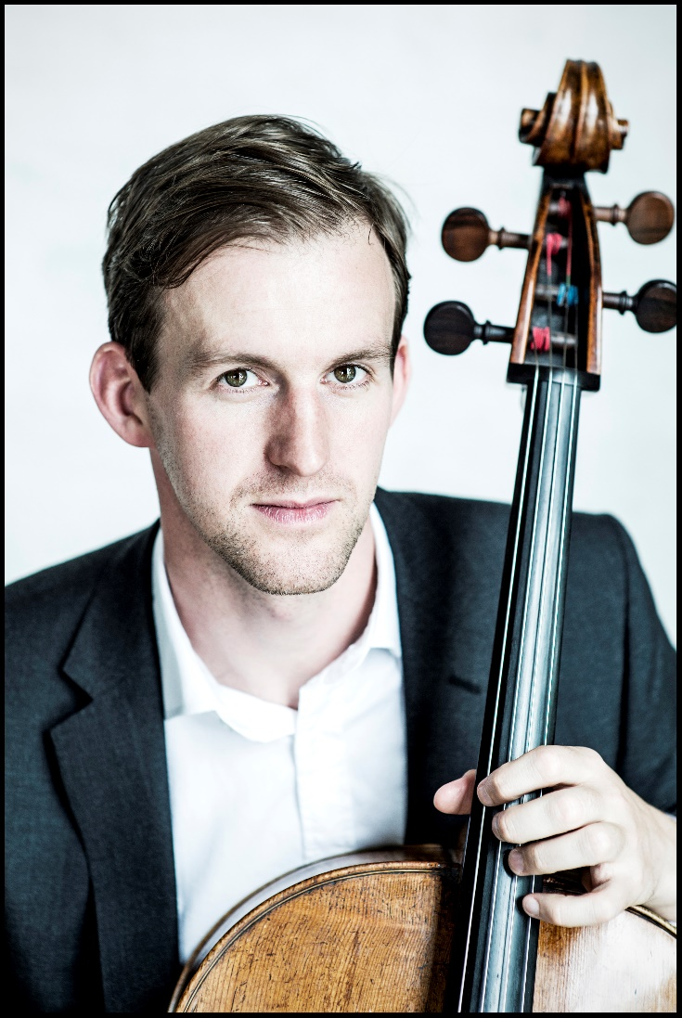
Cello Recital in aid of the Church Organ Fund
With John Paul Ekins on piano
3pm Sunday 23rd September
St Thomas’ Church, Goring
Tickets £12 / £10 (concessions) are available from Inspirations or Elizabeth Parkinson tel. 01491-872020 email parkinsonfamily1@btinternet.com An ‘Early Bird’ discount (tickets £10 / £8) is available for tickets bought before 17th September.

